Procedure for New Tax Year/Summer Tax Billing
This is an overview of the process. The BS&A manual (which can be downloaded from within the module) has a comprehensive checklist and detailed instruction for each of the various steps. Also, review Oakland County’s checklist to the extent that it applies to “stand alone” units such as Southfield.
- Send out New Tax Year Rollout schedule to printer, assessing, IT, Water, and Police (false alarms) in early to mid-May. Send friendly reminder to taxing entities to send L-4029s by June 1st.
  - The State doesn’t issue a L4029 for the SET millage. You must retrieve the certifying letter from their website. https://www.michigan.gov/taxes/property/state-ed-tax
- Create (with IT) new tax year in BS&A (New Tax Year Database Wizard). (Try to do it yourself, but it hasn’t worked for Deputy Treasurer in 2020 or 2021. Worked in 2022, 23!)

- Attach new DB to Shared Database Group in BS&A.

- Set up new tax season in Auto Agent. Set up pre-commitment dates and due dates.

Assessing Import Options (New Tax Year)
- After scheduled cutoff date, request Miscellaneous Totals/Statistics Report (ad valorem) from Assessor.
- Backup Current & New Database before you start.
- File, Import, Various Import to Communicate with other Equalizer…, Equalizer Assessing/Equ…, Direct Import
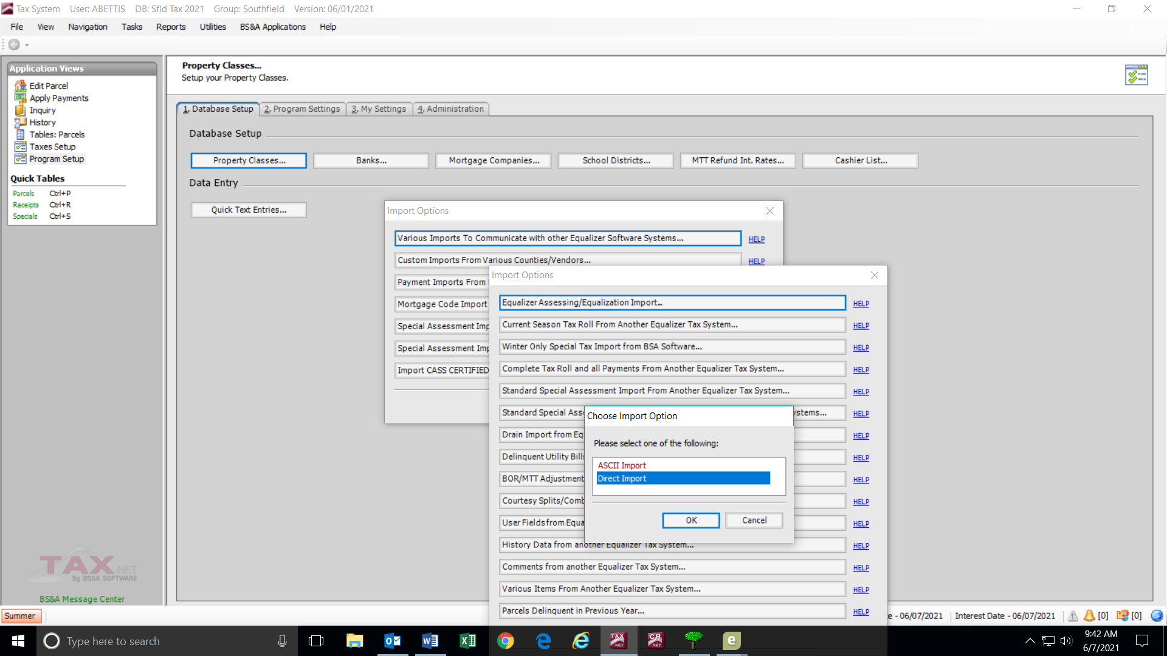
- Yes, to continue (twice).

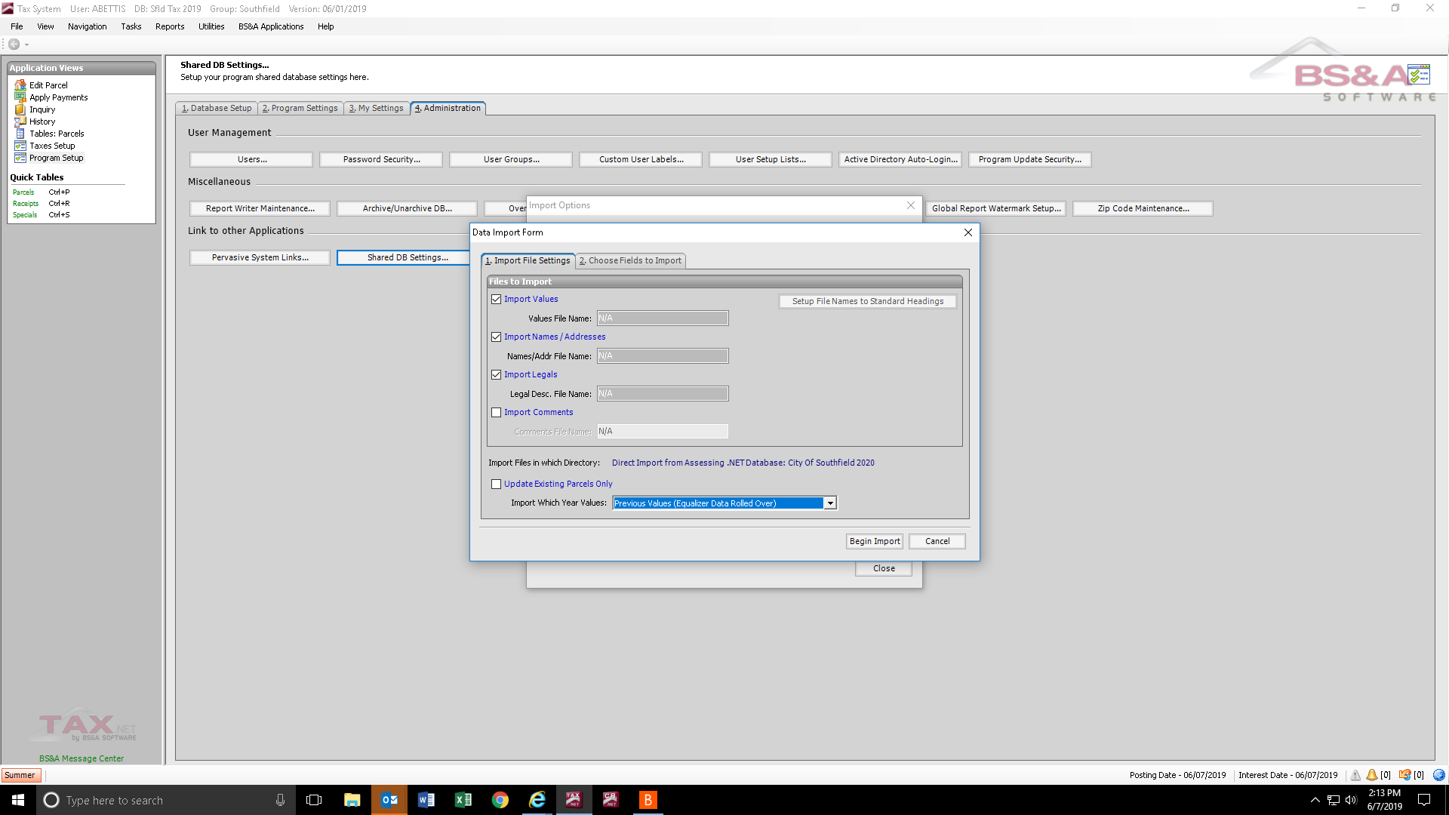
Assessing Year will be one year ahead of the new Tax Year.

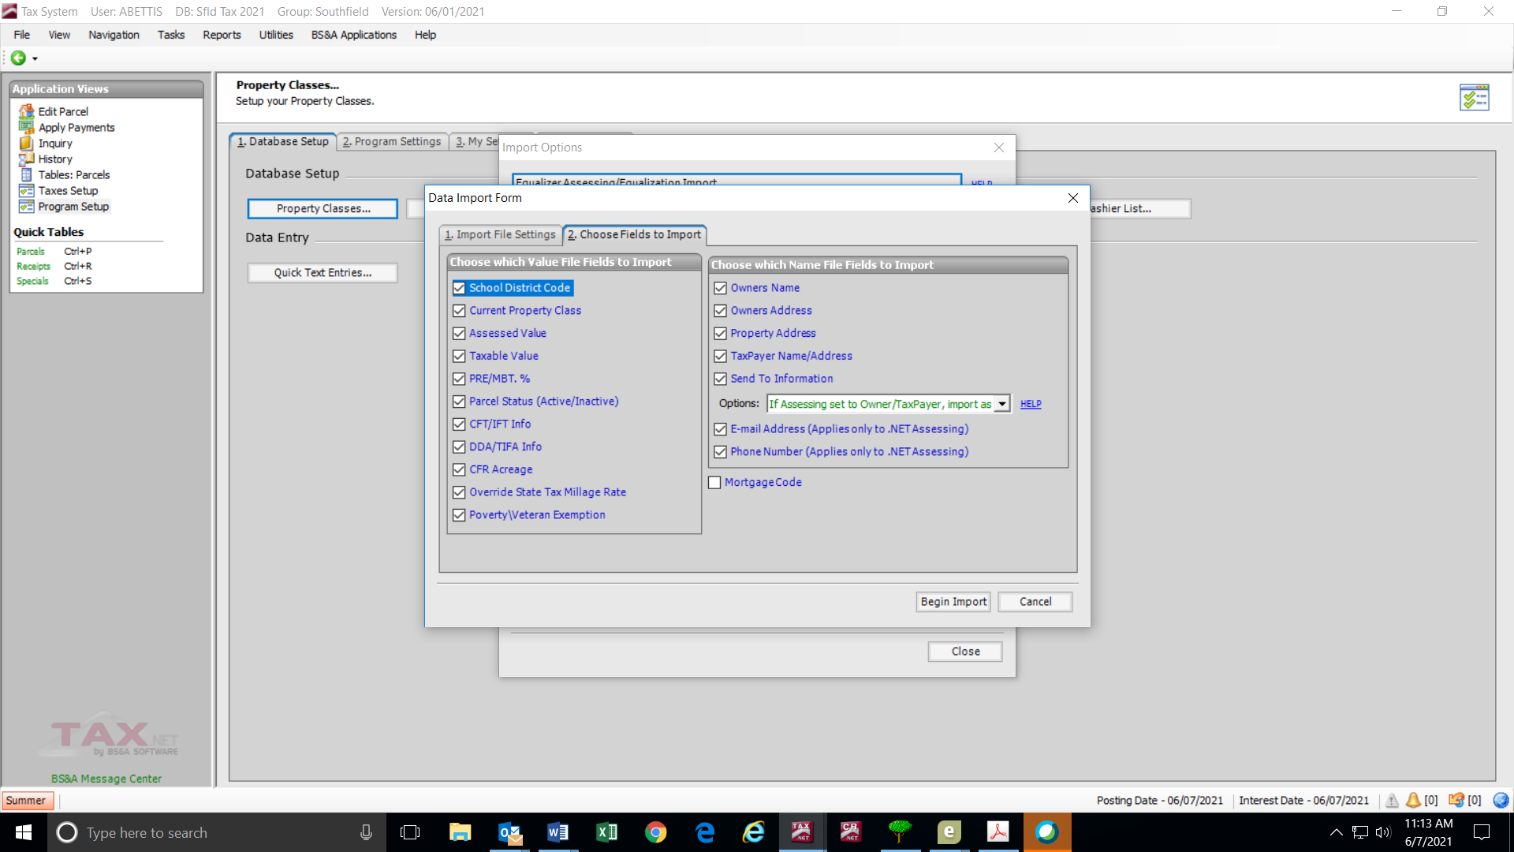
- All records.

- Once Assessing information is imported successfully, run Standard Tax Roll (Reports, Rolls; ad valorem, totals only, summer). Balance SEV, TV for homestead & non-homestead against Miscellaneous Totals/Statistics Report from Assessor.

Enter Millage Rates
Rates will need to be enter in Excel file (for website/printout) and in BS&A (30+ entries) for Ad Valorem and Special Act levies. Do this as early as possible to give Oakland County time to confirm your entries when done. Double check, double check, have someone else (Treasury management) double check!

Imported Files
There are several imports you will receive to import into the new tax year/season. There are instructions in the “permanent” file for each of the various processes. Most are Summer season only.
- The FIRST one that should be done is the import of various data from the prior tax year to the new one. File>Imports>Various imports to Communicate with other…>Various Items from... >Direct Import >All Records> select desired data (see screenshot)
  - Erase all mortgage codes 8010+ (MTT, JBOR, etc.)
- Delinquent Water
- DPW Permits
- Rubbish Fees
- False Alarms
- Miscellaneous Receivables (MR)
- Special Assessments (SA)
- Mortgage Codes (some import files from AutoAgent or individual companies, some manual entry); plus Assessing holdouts (personal property). Summer & Winter
- Oakland County Prior Year Delinquent Flag Summer & Winter

Other Stuff
- In Tax Setup, update the interest/penalty dates.
- In Tax Setup, update the Fiscal Year dates (both seasons). Exhibit below.
- In Tax Setup> General Ledger Setup > Print General Ledger Account Numbers, check for missing GL entries.
- In Tax Setup> Special Assessments/Drains: Add any new special assessment districts (TL, SL, etc) including the “Optional Code” field.
  - In Tax Setup> General Ledger Setup > Special Assessments: Update the new special assessment districts (TL, SL, etc).
- Get Tax Notice published in Southfield Sun, and Cable 15.
  - Also, sent to Communications (Mike Manion) to publish on our website.
- Email Postmaster to open tax PO Box.
- Contact BS&A to activate tax year. Instruct them not to allow payments or show until after midnight, July 1. Also, send email instructing BS&A Online (bsaonlinesupport@bsasoftware.com) to “rollover” your tax year. You will need to provide the exact name of the database. You can send both requests through one tax module support email.
- Set up due dates in Invoice Cloud.
- Bill current year installment for special assessments (tap, contractor, tree, tec.)
- In the Special Assessment module, update installment year (see below).
- Send Fiscal Services (April Gordon) a report of the delinquent water charges rolled to taxes.

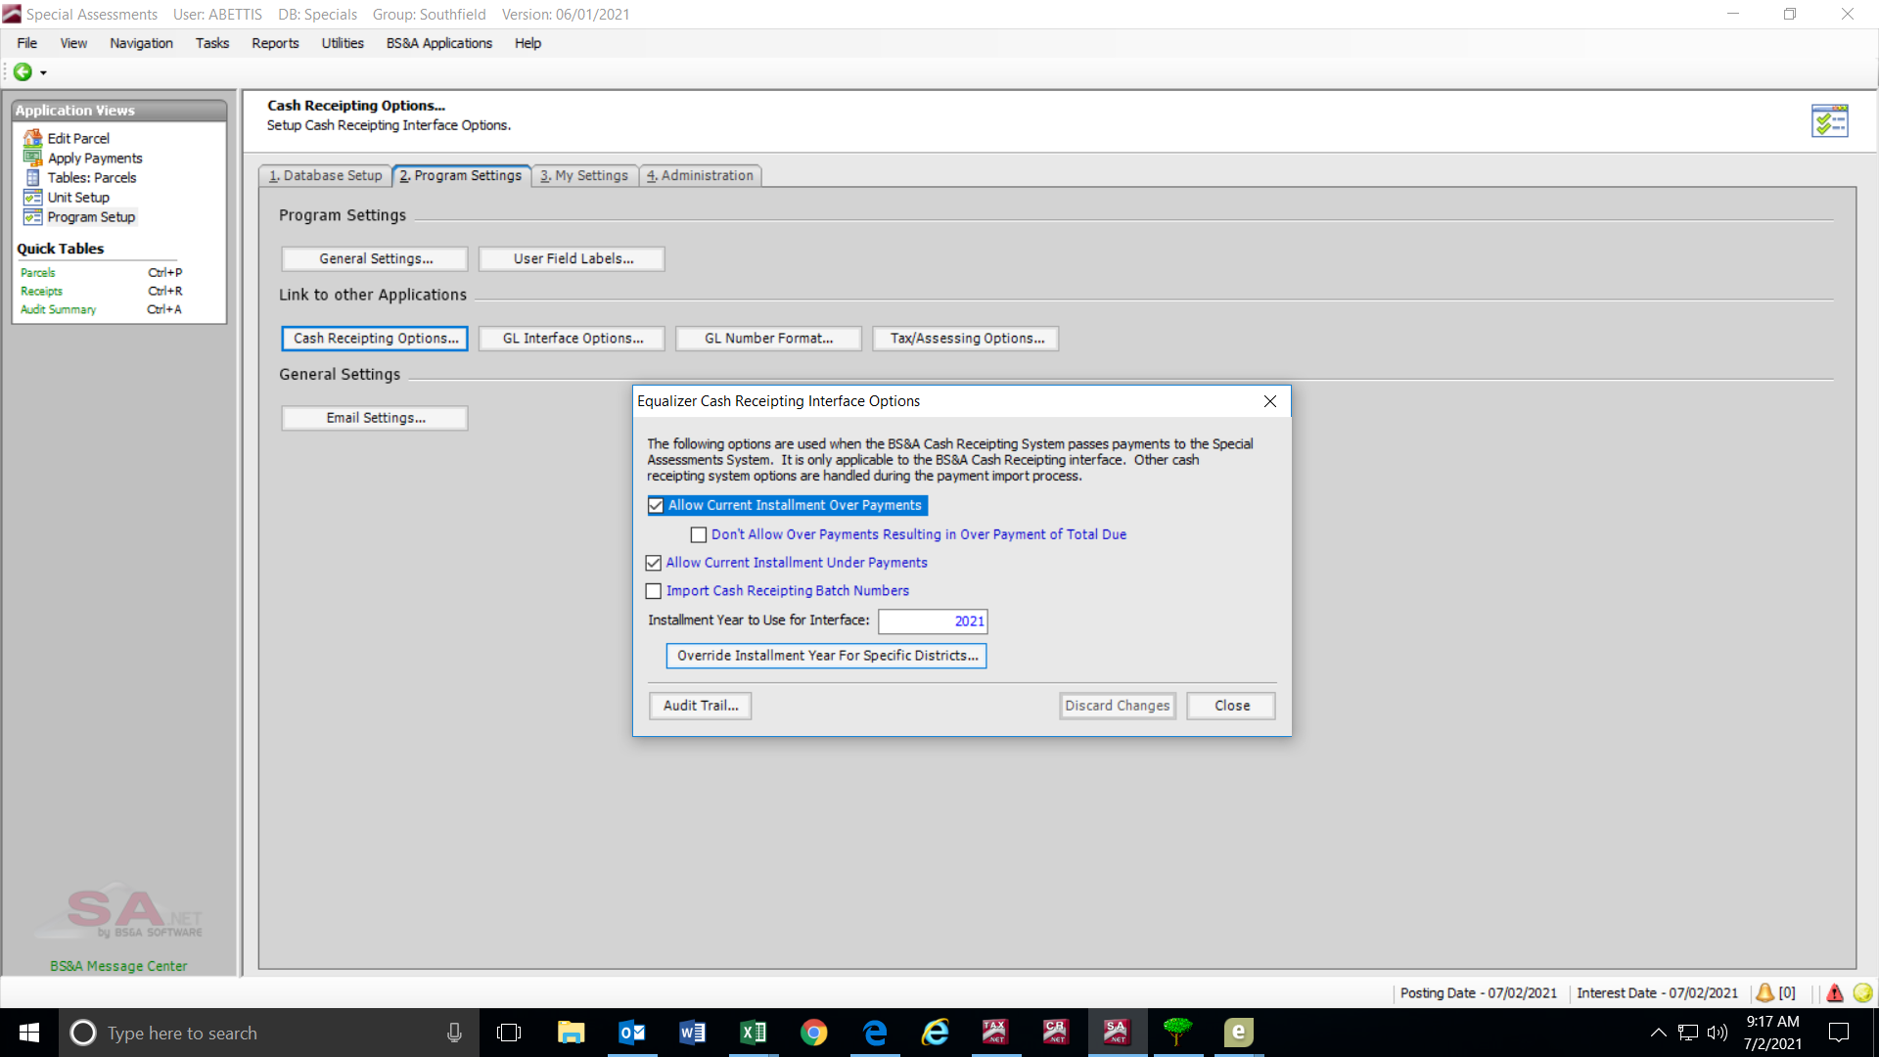

EXPORTS
There are several vendors/partners who are sent exports of our database.
- Whitlock (tax bill printer, at least 2 weeks before July /Dec 1st); Make sure EXCLUDE ZERO TAX BILLS is checked.
  - Whitlock will send sample proofs for the various types of bills. They will be coded:
R= Real Parcels
P= Personal Property Parcel (with envelope so marked)
I= Information copy to taxpayer (mailed later)
M= Mortgage coded copy (sent to my office)
T= Taxpayer copy
  - Check for:
    - Barcodes working properly. Test with all the cashier stations.
    - Prior Year Delinquent flag appears and is spaced correctly.
    - Information copy formatted correctly.
    - Address fit in envelopes correctly.
  - Whitlock overnights sample bills to Alliance (lockbox) to assure scanline works properly.
- Oakland County FTP site; after taxes are committed in BS&A
- Invoice Cloud (online payment processor)
  - To avoid “duplicate” tax bills from appearing in Invoice Cloud (for the parcels that send bills to both Taxpayer and Owner), see 7/14/22 email from BS&A Tax Support, and run process that will eliminate problem BEFORE sending export to Invoice Cloud.
- Alliance (lockbox payment processor); .CIF file. In the Tax module:
  - File, Export, Generic Data Export
  - Click on the Load from DB icon; Select SUMMERCIF
  - Fields should show: CSV file type, all records, sort by parcel#, and fields to export (parcel#, owner name, property address, summer tax balance). Filename should be: L:\TREAS\20xx Taxes\SUMCIF.CSV.
  - Click on Export Data icon. Takes about 10 minutes. Make a zip file. No need to view. Use a unique file name for zip file (20xx Summer CIF File-Alliance).
  - Email zip file to Alliance/Lockbox (Mini James & Operations)
  - Send this file periodically throughout tax season to allow duplicates and overpayments to be caught.

AFTER DELIVERY
When smaller mortgage parcels are delivered by printer:
- Send Oakland County (Jessica) by mail & email a blank sample tax bill (back & front).
- Print mortgage company address labels from BS&A
  - Program Setup; Mortgage Companies; Printer Icon, Labels
- Print mortgage company Bar Code Sheets
  - Reports> Parcel reports> Mortgage Code/Parcel# w/barcode> Standard Barcode to be read directly
  - BLOCK (all but the “big 3”; 2-41, 50-183, 199-299 for example)

